JAVA Logical Coding Programs

1.Write Java Program to check print Armstrong Number

public class Main

{

public static void main(String[] args) {

int arm=0, a,temp=0;

int n=153;

temp=n;

while(n>0)

{

a=n%10;

n=n/10;

arm=arm+(a\*a\*a);

}

if(temp==arm)

System.out.println(temp +" the armstrong number ");

else

System.out.println( temp+ " the not armstrong number " );

}

}



2. Write Java Program to check print Even or Odd Number

public class HelloWorld{

public static void main(String []args){

System.out.println("even number");

for(int i=0;i<=100;i++)

{

if(i%2==0)

{

System.out.println(i);

}

}

System.out.println("odd number");

for(int i=0;i<=100;i++)

{

if(i%2!=0)

{

System.out.println(i);

}

}

}

}

3. Factorial Number

class Factorial {

public static void main(String []args)

{

int n=10;

int fact=1;

System.out.println("Finding a Factorial of number\n");

for( int i=1;i<=n;i++)

{

fact=fact \* i ;

}

System.out.println(n+" factorial of number is "+fact); //

}

}

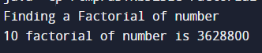

4. Prime Number

public class PrimeNumber{

public static void main(String[] args) {

int n=6,i,m=0, flag=0;

m=n/2;

System.out.println("Prime Numbers are");

if(n==0 || n==1)

{

System.out.println(n+" not prime number ");

}

else{

for(i=2;i<=m;i++){

if(n%i==0){

flag=1;

System.out.println(n+" not prime number");

break;

}

}

}

if(flag==0)

{

System.out.println(n+" is prime number");

}

}

}

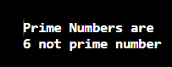

5. Swap to number without using third variable

public class MyClass {

public static void main(String args[]) {

int x=10;

int y=20;

System.out.println("Swap Number without using third variable");

x=x+y;

y=x-y;

x=x-y;

System.out.println("The value of x is " +x);

System.out.println("The valuee of y is " +y);

}

}

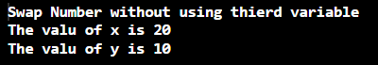

6. Swap to number with using third variable

public class Swap {

public static void main(String args[]) {

int x=10;

int y=20;

int temp;

System.out.println("Swap Number without using thierd variable");

temp=x;

x=y;

y=temp;

System.out.println("The value of x is " +x);

System.out.println("The value of y is " +y);

}

}

7.W.A Program to reverse a number

public class Reverse {

public static void main(String args[]) {

int rem,rev=0,n=134;

while(n>0)

{

rem=n%10;

rev=rev\*10+rem;

n=n/10;

}

System.out.println("The reverse number is " +rev);

}

}

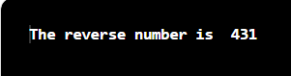

8.W. A Program to Sum of digit

public class SumofDigit {

public static void main(String args[]) {

int rem=0,sum=0,n=324;

while(n>0)

{

rem=n%10;

sum=sum+rem;

n=n/10;

}

System.out.println("Sum of degit is = " +sum);

}

}

9.W.A. Program to find Fibonacci series

public class SumofDigit {

public static void main(String args[]) {

int n1=0,n2=1,n3,count=5,i;

System.out.println("Fibonacci number");

for(i=2;i<=count;i++)

{

System.out.println(n1+" "+n2);

n3=n1+n2;

System.out.println("fibonacci series is = " +n3);

n1=n2;

n2=n3;

}

}

}

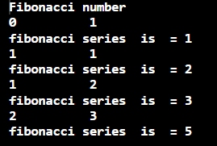

10.Reverse a String